Name | Subject Class | Class | Index Number
 | 2BI



ANGLO-CHINESE JUNIOR COLLEGE

Preliminary Examination 2021

BIOLOGY 9744/03

HIGHER 2 31 August 2021 Paper 3 Long Structured and Free-response Questions 2 hours

READ THESE INSTRUCTIONS FIRST

Write your name, subject class, form class and index number on all the work you hand in.
Write in dark blue or black pen.
You may use a soft pencil for any diagrams, graphs or rough working.
Do not use staples, paper clips, highlighters, glue or correction fluid.

Section A
Answer all questions in the spaces provided on the Question Paper.

FOR EXAMINER’S USE
1
2
3
4 or 5
TOTAL
75
Section B
Answer any one question on the separate writing paper provided.

The use of an approved scientific calculator is expected, where appropriate.
You may lose marks if you do not show working or if you do not use appropriate units.

At the end of the examination, fasten your work securely together.
The number of marks is given in brackets [ ] at the end of each question or part question.

This document consists of 15 printed pages.
Section A

Answer all the questions in this section.

- Fig 1.1 shows part of the reproductive cycle of the influenza virus in an infected cell.

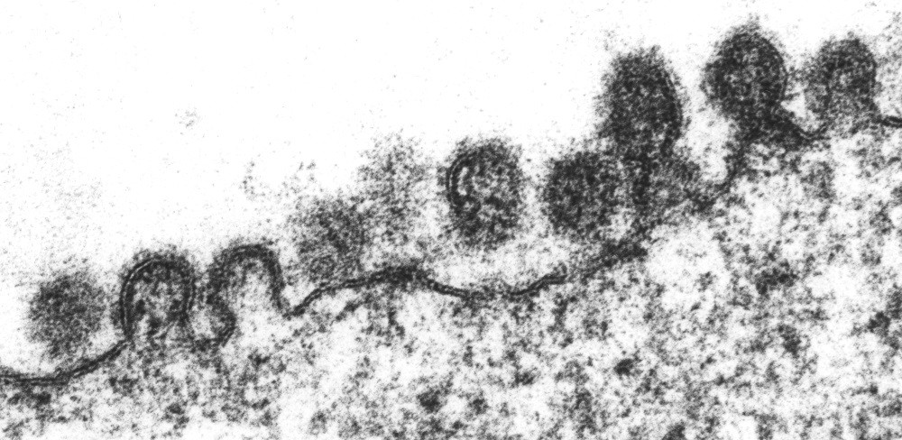

Fig. 1.1

- Describe the part of the influenza virus reproductive cycle shown in Fig. 1.1.
- Assembly of the viral particles as viral glycoproteins, haemagglutinin and neuraminidase, are inserted into the cell surface membrane;
- Ribonucleoproteins / RNA genome and the nucleocapsid proteins are transported near the cell surface;
- Release of the viral particles via budding;
- Cell surface membrane of hose cell evaginates, allows the viral particles to pinch off / cell surface membrane of host cells now becomes the viral envelope of a newly formed viral particles;
- Neuraminidase has cleaved the sialic acid residues from the host cell receptors and viral particles detach/release;
Max 3m | [3]

A study was carried out to determine the factors that affect the replication of influenza virus. In a single-cell analysis, one viral-infected cell was transferred to each well on a 384-well plate (Fig. 1.2). As the virus replicates in the cell, the viral particles are released from the cell into the well.

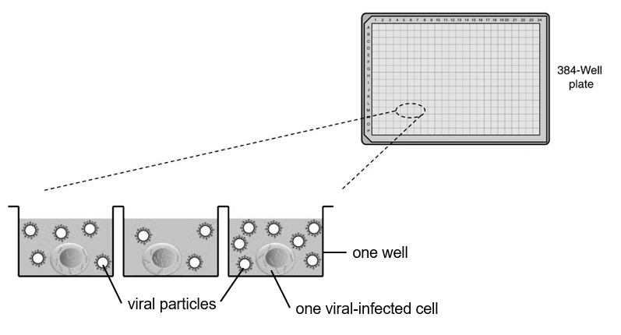
Fig. 1.2

To ensure that the cells placed in the wells are all infected by the influenza virus, the scientists also measured the infection of the cell and the state of the cell after exposure to the virus.

Fig. 1.3 shows the proportion of cells infected and the proportion of cells undergoing apoptosis on the plate.

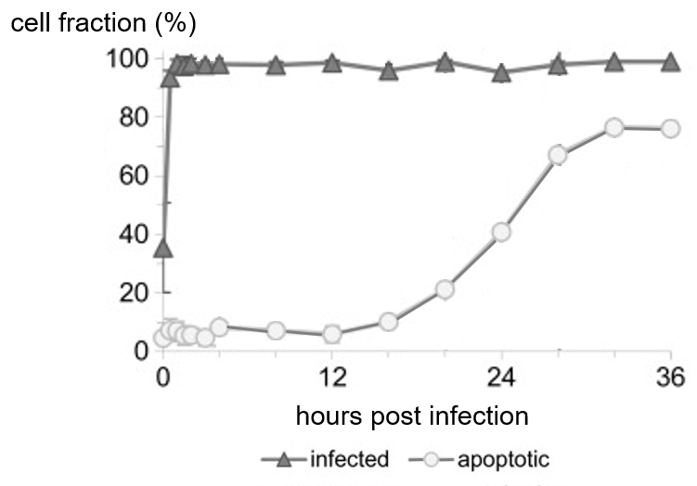

Fig. 1.3

The virus yield per cell, which is the number of infectious viral particles released from each cell, was determined. The diameter of each infected cell is also measured. The results are shown in Fig. 1.4a and Fig. 1.4b. The first bar on the left of the histogram in Fig. 1.4a indicates the fraction of cells that shows no release of viruses.

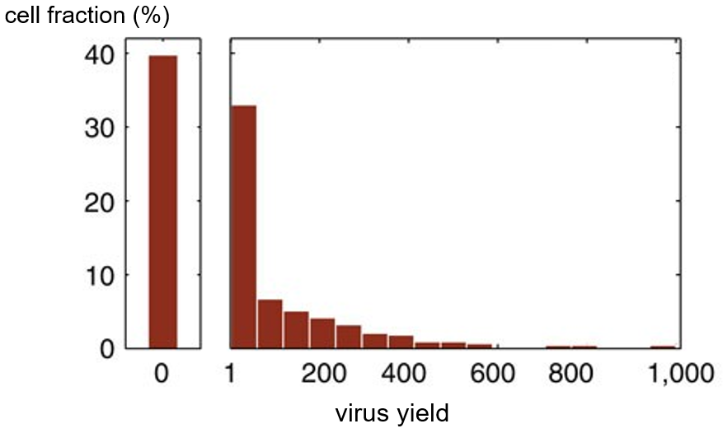
Fig. 1.4a

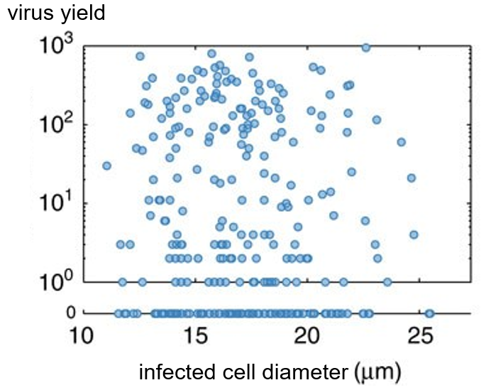
Fig. 1.4b

- (i) With reference to Fig. 1.4b, comment on the relationship between the diameter of the viral-infected cell and the virus yield.
- There is no correlation between the cell diameter and the number of infectious viral particles per cell;
- The number of infectious viral particles can range from 0 per cell, to about 1000 per cell regardless of the cell diameter from 12 to 25.5µm;
[2]

(ii) Given the formula of the surface area of a sphere is 4πr², calculate the area of the cell surface membrane of a viral-infected cell with a diameter of 15 µm. Show your workings and present your answers in nm².
- Conversion of units: 15 µm = 15 000 nm
Radius = 15000 nm / 2 = 7500nm;

- Area = 4πr² = 4 π (7500)(7500) = 706858347 nm² = 710000000 nm² (2 s.f.);
[2]

(iii) The average diameter of the viral particles released in the early phase of an infection is approximately 120 nm. Determine the maximum possible number of viral particles that can be released from a viral-infected cell with a diameter of 15 µm. Show your workings.
- Area of viral envelope = 4πr² = 4 π (60)(60) = 45239 nm²;

- 706858347 nm² / 45239 nm² = 15624 = 16000 (2 s.f.);
To consider ECF from (ii) | [2]

(iv) The observed maximum number of viral particles released from each viral-infected cell (Fig. 1.4a and 1.4b) differs from the maximum possible number of viral particles released (from calculations in (b)(iii)).

With reference to all the information provided, suggest a reason for this difference.
- [Data] Fig 1.4a / Fig 1.4b shows a maximum actual number of 1000 / slightly less than 1000 (for 15 µm cell diameter) infectious viral particles per cell, much smaller than the maximum possible number;
- [Reason] The viral infected cell underwent apoptosis, before all the viral particles can fully assemble / yielding more viral particles;
- [Data of reason] From Fig. 1.3, the graph shows that from 12 hours to 32 hours post infection, the fraction of the cells which are apoptotic increases from 5% to 75%;
[3]

Fig. 1.5 shows the structures of sialic acid and two antiviral drugs, Zanamivir and Oseltamivir. Both antiviral drugs target neuraminidase (NA).

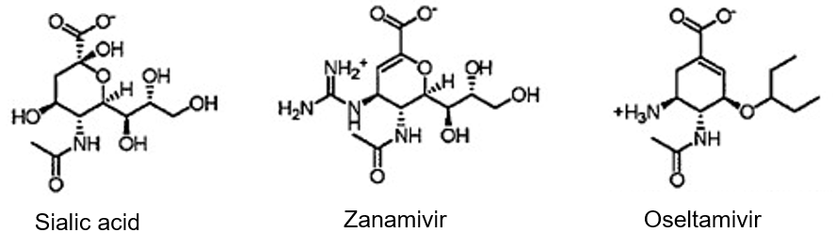
Fig. 1.5

- (i) With reference to Fig. 1.5, deduce how Zanamivir and Oseltamivir inhibit the action of neuraminidase.
- Zanamivir and Oseltamivir are competitive inhibitors of neuraminidase;
- Zanamivir and Oseltamivir are structural analogues/similar 3D conformation to sialic acid, the monomer of the substrate of neuraminidase and bind to active site of neuraminidase
OR complementary to the 3D conformation of the active site of neuraminidase;
- Prevents neuraminidase from binding to the substrate/sialic acid/ receptor containing sialic acid / prevent formation of enzyme-substrate complex;
[3]

(ii) Zanamivir is administered via inhalation, while Oseltamivir is a tablet that is taken orally. Suggest an advantage of administering the antiviral drug via inhalation.
- More of the drug will be made available at the target site/respiratory tract as the liver will not break it down so quickly upon administering/digestive enzymes do not act on the drug;
- Faster onset of action as the medication is introduced directly to the respiratory tract where the host cells of the virus are found;
- Fewer side effects, since it is not circulated through the entire body, but only acts locally at the respiratory tract;
Note! Should have reason accompanying | [1]

It is uncommon for humans to be directly infected with avian flu virus and for the infected human to transmit the virus to another human. This is termed as “host restriction”.

Transmission typically requires an intermediate host, often referred to as a “mixing vessel”, in order for new viruses to cross the species boundaries from birds to humans (Fig. 1.6).
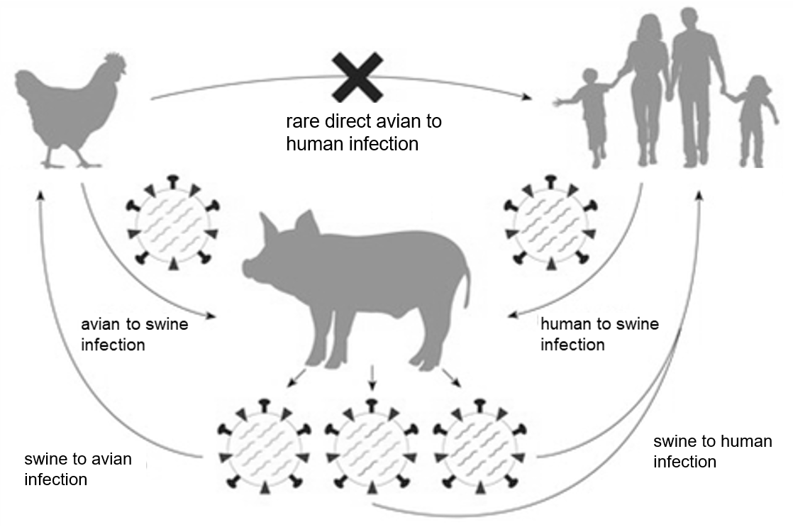
mixing vessel
Fig. 1.6

Host restriction of each influenza virus is the result of the interaction between its haemagglutinin (HA) and a specific sialic acid receptor found on the specific host cell. The type of sialic acid receptors found on the different host cells is shown in Table 1.1.

Table 1.1

Type of host cells | Type of glycosidic bond found between the last sialic acid to the oligosaccharide chain on the cell surface glycoprotein
Human | α 2–6 linkage
Avian | α 2–3 linkage
Swine | α 2–3 linkage and α 2–6 linkage

- (i) Outline the synthesis of the sialic acid receptors in the host cells.
- Transcription of the gene coding for sialic acid receptor occurs in the nucleus;
- Translation occurs at the ribosomes on the rough endoplasmic reticulum, the polypeptides enter the RER lumen;
- Polypeptide/protein is transported to the Golgi apparatus / RER for glycosylation / addition of oligosaccharide including sialic acid; R! PTCM, as need context | [2]

(ii) Suggest why swine is suitable as a “mixing vessel” that allows a virus to cross the species boundary from birds to humans.
- Swine cell contains sialic acid receptors with α 2–3 linkage and sialic acid receptors with α 2–6 linkage;
- This allows the influenza virus that infects avian cells and virus that infects human cells to infect the same swine cell;
- allowing for antigenic shift where there is an intracellular recombination of the genome segments;
- Giving rise to a new viral strain with modified haemagglutinin that can bind to receptors with α 2–6 linkage on human cells;
- antigenic drift can contribute, random mutations in the HA gene of the avian virus results in modified haemagglutinin that can bind to receptors with α 2–6 linkage on human cells;
max 3m
[3]

- Explain how specific features of the influenza genome allow variation in the viral genome to arise over time.
- single-stranded negative sense RNA;
- RNA is more unstable / reactive than DNA, allowing a higher rate of accumulation of mutations / allowing antigenic drift;
- 8 segments;
- Segments allow reassortment / new combinations of genome segments when 2 or more strains infect the same cell at the same time / antigenic shift;
R! lack of proofreading ability by RNA-dependent RNA polymerase | [4]

Scientists study the evolution of influenza viruses so as to predict new viral variants and design vaccines. One way to study the evolutionary history of the viruses is through phylogenetic analysis of viral genetic sequences such as the HA gene. Fig. 1.7 shows the phylogenetic relationships between the 18 different HA subtypes (H1 to H18). Group 1 HA polypeptide molecules share a highly conserved amino acid sequence, which is different from that shared among the Group 2 HA molecules.
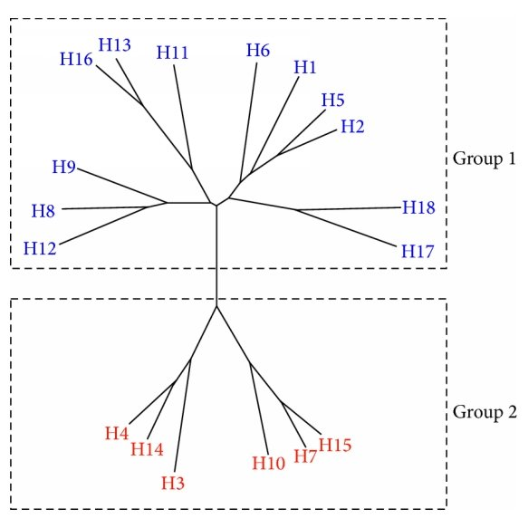
Fig. 1.7

- Using the information provided, explain how a named selection pressure can result in the evolution of influenza viruses.
- Variation in the HA genetic sequences could have arose due to accumulations of random mutations / antigenic drift;
- [Named selection pressure] Presence of antibodies specific for the haemagglutinin subtypes (due to vaccination/increased infection or exposure to the strain) /
Availability of different hosts / presence of different sialic acid receptors;
- Viruses with a different HA subtype that is not recognised by the antibodies / able to bind to the different sialic acid receptors found on cells in hosts available in the environment will be selected for;
- Over time, changes in the allele frequency of the gene pool of the virus population;
- Different alleles of the haemagglutinin gene resulting in the different strains / different HA subtypes;
- There is an early divergence of the ancestral population into 2 groups (Group 1 and Group 2), and further divergence into subtypes; | [4]

[Total: 29]
- Fig. 2.1 shows the levels of Mycobacterium tuberculosis (also known as bacterial burden) in an infected person, measured using bacterial antigen levels in the bloodstream. The patient received treatment for the disease which was administered orally, but a repeated treatment was required when the first treatment proved ineffective.
Bacterial burden
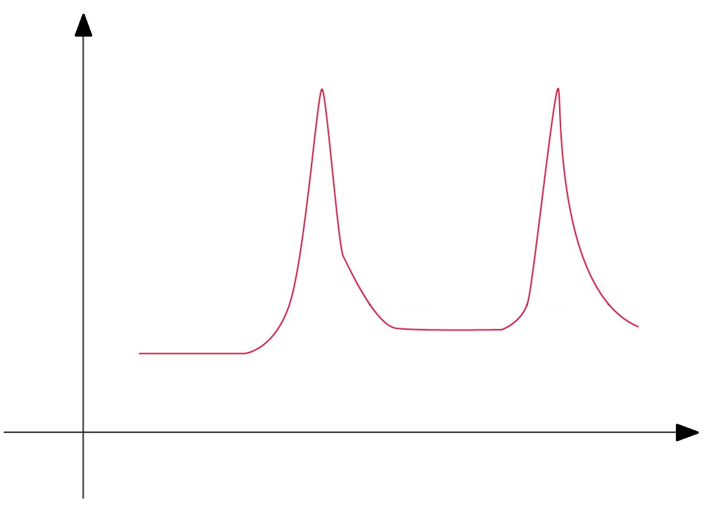
X
First Treatment
Repeated Treatment
Time

Fig. 2.1

(a) (i) With reference to Fig. 2.1, account for the changes in bacterial burden during the time period labelled X.
ori
ori
- Bacterial burden initially remained constant; R! low
- As the bacteria remains dormant / latent within granulomas / tubercles, surrounded by T cells and macrophages;
- The bacteria survives within infected macrophages because it secretes a protein that inhibits the fusion of phagosomes with lysosomes / phagolysosome cannot be formed /
its lipid shell comprising mycolic acid protects the mycobacteria against lysozymes/reactive oxygen radicals in the phagosomes;
- Bacterial burden then increases sharply;
- If the patient’s immune system is weakened / patient becomes immunocompromised due to immunosuppressive drugs / other diseases;
- the caseous centre of the granuloma undergoes liquefaction, and the granuloma ruptures to release the contained bacteria;
[5]

(ii) Deduce the likely treatment that the patient received and describe one possible mechanism of this treatment.
- Antibiotics was given;
- Inhibit the transpeptidation / cross-linking of peptidoglycan during cell wall synthesis /
disrupt the phospholipid bilayer of the cell surface membrane /
inhibit the synthesis of nucleotides required for DNA replication/synthesis of DNA /
inhibit the enzymes involved in DNA replication/synthesis of DNA /
inhibit RNA polymerase in transcription / synthesis of RNA /
inhibit 70S ribosomes in translation/synthesis of polypeptides;
(any one mechanism) | [2]

(iii) Suggest why the treatment administered may be ineffective in curing the infection.
ori
ori
- Some bacterial cells were resistant to the antibiotics given /
only one antibiotic type is given but several antibiotics need to be administered at the same time to be effective /
antibiotics was unable to effectively target cells contained in granulomas R! macrophages only /
antibiotics was ineffective against cells which are not actively dividing; (any one reason)
Antibiotic dosage not sufficient to eliminate all bacteria
AVP; | [1]

It has long been believed that antibody responses have a limited effect on an infection by Mycobacterium tuberculosis.

(b) With reference to one function of antibodies, explain the reason for this belief.
- Binding of antibodies to the bacteria surface antigens may facilitate phagocytosis by macrophages in the process of opsonisation;
- Antibodies are unable to bind to bacteria cells which are reproducing within infected cells / found intracellularly/ contained in granuloma OR
Facilitating phagocytosis will allow for M. tb replication / unable to be digested within the cell and M. tb will not be removed effectively;
OR
- Binding of antibodies to the bacteria surface antigens may activate the complement system and trigger the formation of pores in the cell surface membrane, leading to osmotic lysis of the bacterial cells OR
Binding of antibodies to the bacteria surface antigens may activate the complement system and enhances phagocytosis of the bacterial cells;
- Antibodies are unable to bind to bacteria cells which are reproducing within infected cells / found intracellularly/ contained in granuloma OR
mycolic acid found as part of the bacteria cell wall protects the cell from being targeted by proteins of the complement system / prevent phagocytosis;
R! Neutralisation as bacteria entry into macrophages is a pre-requisite for infection by M. Tb  R! Mutations in the bacteria DNA resulting in changes in the 3D configuration of antigen such that antibodies cannot bind as this point is not specific to features of M. tb | [2]
[Total: 10]

- The behaviour of animals is determined by both their genetic make-up and the environment in which they are in.

(a) Explain how both the genetic make-up of animals and the environmental conditions they live in determine their behaviour.
- Genes are transcribed to mRNA which are translated to proteins;
- These proteins could be enzymes involved in physiological processes / metabolic / transport / structural functions which determines the phenotype of the organism;
- Environment influences the degree of expression of genes, leading to different amount of proteins expressed;
[3]

The introduction and establishment of non-native species often changes the ecological relationships in the recipient ecosystem. The northern pike (Esox lucius) is an example of a non-native species of fish that has been introduced into some large lakes in America. This fish feeds mainly on invertebrates, but when a suitable fish prey is available, it becomes piscivorous (feeds on fish). One species of fish that the northern pike feeds on is the brown trout (Salmo trutta).

Fig. 3.1a shows the effect of temperature on the attack rate of northern pike on its prey, brown trout. The attack rate reflects the frequency at which northern pike searches for the brown trout. Two groups of northern pike were subjected to either a short or long starvation time. Fig. 3.1b shows the effect of temperature on the swimming speed of northern pike and brown trout.

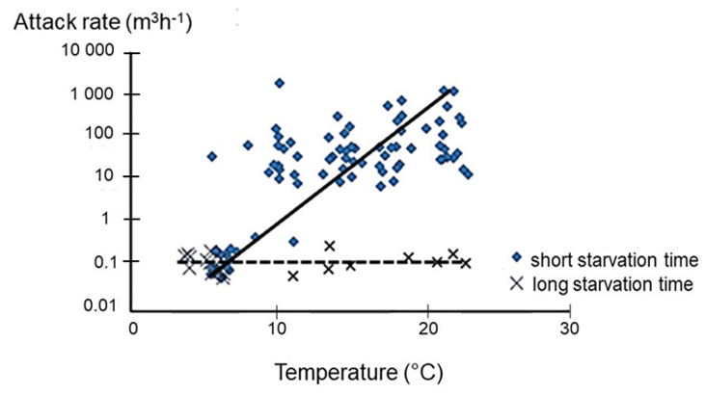

Fig. 3.1a

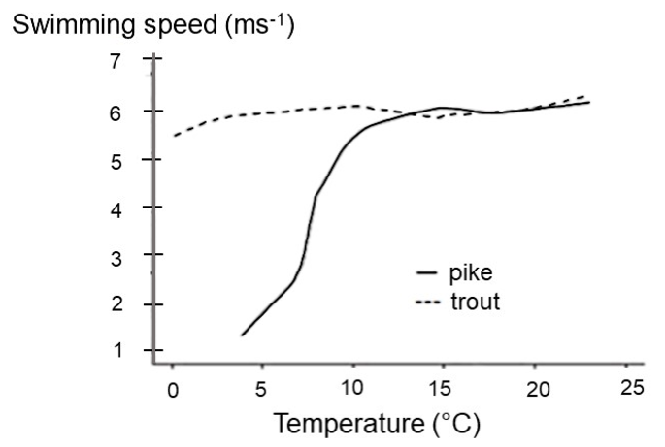

Fig. 3.1b

(b) (i) Describe the effect of temperature and starvation time on the attack rate of northern pike.
- The attack rate of northern pikes increases with increasing temperature in populations of northern pikes with a short starvation time;
- The attack rate increases from between 0.01 to 0.1 m³h⁻¹ at 5°C to 1000 m³h⁻¹ at 21°C OR
The attack rate increases from between 0.01 to 0.1 m³h⁻¹ at 5°C to slightly above 1000 m³h⁻¹/ between 1000 to 10000 m³h⁻¹ at 22.5°C (A! 22 – 23°C);
- The attack rate of northern pikes remains constant with increasing temperature in populations of northern pikes with a long starvation time;
- The attack rate remains at 0.1m³h⁻¹ from 2.5°C (A! 2 to 3°C) to 22.5°C (A! 22 to 23°C);
[4]

Brown trout thrives in Lake Michigan, one of the five great lakes of North America. Lake Michigan is the second-largest of the great lakes in America and spans 494 km long and 190 km wide with the greatest depth of 281 m. The surface temperature of the lake surface averages 20°C, while the temperature of the lake drops on an average of 2.5°C for every 500 m.

When northern pike was introduced into Lake Michigan, the population of brown trout decreased.

(ii) Calculate the expected water temperature at the deepest part of the lake. Show your workings.

- Expected drop in temperature = [(281/500) x 2.5°C] = 1.4°C;
- Expected water temperature = 20°C – 1.4°C = 18.6°C OR 19°C;

[2]

(iii) Using the calculated temperature in (b)(ii) and data provided in Fig. 3.1a and 3.1b, predict the likely effect of increasing temperature on the behaviour of the two species of fishes.
- At temperature higher than 18.6°C, the attack rate of northern pike with short starvation time may increase to between 100 to 1000 m³h⁻¹, however, the swimming speed of northern pike is the same as the trout’s escape/swimming speed at 6 ms⁻¹;
- Therefore, it is likely that the attacking northern pike will be able to swim and reach the escaping trout and eat it;
[2]

[Total: 11]

Section B

Answer one question in this section.

Write your answers on the separate writing paper provided.

Your answers should be illustrated by large, clearly labelled diagrams, where appropriate.

Your answers must be in continuous prose, where appropriate.

Your answers must be set out in parts (a) and (b), as indicated in the question.

4 | DNA contains thousands of genes which code for proteins that dictate cell function. Gene expression is tightly controlled. The regulation of gene expression involves different biomolecules, and is important for cellular activities such as cell and nuclear division.
 | (a) | Describe how ribonucleic acids are involved in the flow of information from DNA to proteins. [15]
 | (b) | Describe the events that occur during interphase of the cell cycle in preparation for cell and nuclear division and explain why it is important to regulate these events at appropriate time points. [10]
 |  | [Total: 25]
5 | Two groups of genes are involved in regulating the cell cycle, where the actions of the proteins of these two groups of genes counteract each other to achieve a balance between cell division and cell death. Mutations, which either affect individual genes or large segments of the chromosome, may lead to the development of cancer.
 | (a) | Explain how mutations affecting the two groups of genes involved in cell cycle regulation may lead to the development of cancer. [15]
 | (b) | Outline the techniques by which mutations, either affecting individual genes or large segments of the chromosome, may be identified in an individual. [10]
 |  | [Total: 25]

[End of Paper]

Essay Answers

4 | DNA contains thousands of genes which code for proteins that dictate cell function. Gene expression is tightly controlled. The regulation of gene expression involves different biomolecules, and is important for cellular activities such as cell and nuclear division.
 | (a) | Describe how ribonucleic acids are involved in the flow of information from DNA to proteins. [15]
    - (m/r/t)RNA synthesised in nucleus via transcription / rRNA synthesised in nucleolus via transcription;
    - And they are complementary to template strand of gene;
    - RNA is transported from nucleus to cytoplasm through nuclear pores;

mRNA:
    - mRNA serves as a template;
    - which is read by the ribosome for the synthesis of a polypeptide / translation;
    - each codon in the mRNA codes for an amino acid;
    - sequence of codons on mRNA translated to specific amino acid sequence of polypeptide;
    - *codons on mRNA base-pair with complementary anticodons on tRNA by (hydrogen bonds);
    - mRNA also contains start codon to ensure that translation begins / initiates at the correct point;
    - mRNA also contains stop codon to ensure that translation ends / terminates at the correct point;

rRNA (award pt 13-16 only if rRNA was mentioned):
    - rRNA complexes with ribosomal proteins to form ribosomal subunits / ribosomes;
    - Ribosomal subunits assemble / associates / joins to form a ribosome during translation / polypeptide synthesis;
    - rRNA forms part of the small subunit which recognises and binds to the 5’ end / 5’ UTR of the mRNA;
    - rRNA allows for the formation of E, P, A sites of the large subunit;
    - rRNA helps to align / orientates / positions mRNA within the sites in the ribosome for complementary base pairing with tRNA;
    - Part of rRNA has peptidyl transferase activity to catalyse formation of peptide bonds between adjacent amino acids;

tRNA:
    - Its function is to carry the amino acid to the ribosome;
    - The 3’ end with CCA nucleotides serves as a site of attachment for specific amino acids;
    - tRNA molecules become attached to specific amino acids through aminoacyl-tRNA synthetases;
    - tRNA has a specific 3D conformation / clover-leaf structure allows for interaction with aminoacyl-tRNA synthetase / large ribosomal subunit;
    - It has an anticodon that determines which amino acid binds to the tRNA molecule;
    - *codons on mRNA base-pair with complementary anticodons on tRNA by (hydrogen bonds);
    - The tRNA carrying methionine / initiator tRNA will help initiate translation;

    - QWC – mRNA 1 point (pt 4-10), rRNA 1 point (pt 11, 13-16), tRNA 1 point (pt 17-23)

*Mark once for points 8 & 22
4 | (b) | Describe the events that occur during interphase of the cell cycle in preparation for cell and nuclear division and explain why it is important to regulate these events at appropriate time points. [10]

Interphase events (pt 1 – 8, max 6 marks)
- During the G₁ / G2 phases of interphase;
- increase in cell size;
- Synthesis of proteins / translation occurs;
- There is synthesis of cellular organelles e.g. mitochondria, chloroplasts and centrioles to allow for equal division into the daughter cells;
- There is synthesis of ATP in preparation for the energy consuming processes during cell division;
- During S phase of interphase, semi-conservative DNA replication occurs;
- Each parental DNA strand serves as a template to form daughter DNA molecule made up of 1 parental strand and 1 newly synthesised / daughter strand;
- The amount of DNA content / (total) number of DNA molecules doubles; R! ploidy

Importance to regulate events (pt 9 – 18, max 6 marks)
- G₁ checkpoint checks for the presence of proteins that are required to stimulate cell division / growth factors;
- G₁ checkpoint Checks for DNA damage;
- G₁ checkpoint Checks for cell size;
- G₁ checkpoint Checks that nutrients are sufficient;

- G₂ checkpoint assesses if DNA is replicated without damage / correctly replicated;

- Progression of the cell cycle is delayed / arrested / prevent initiation of next phase (e.g. S phase / mitosis) if problems are detected;
- If there is irreparable damage / DNA beyond repair at either G₁ or G₂, cell death is induced / apoptosis occurs; R! necrosis
- Preventing accumulation of mutations in a single cell lineage OR ensuring that incompletely replicated DNA / mutated genetic material / errors in DNA is not distributed / passed down to daughter cells;
- such as cancer critical genes / genes controlling anchorage dependence / density-dependent inhibition / angiogenesis / metastasis / coding for telomerase;
- which may lead to the development of cancer / uncontrolled cell division;

- QWC: G1 or G2 phase and S phase (1m from pt 1-8) must be described, importance of G1 checkpoint (1m from pt 9-12) and G2 checkpoint (pt 13 compulsory);

5 | Two groups of genes are involved in regulating the cell cycle, where the actions of the proteins of these two groups of genes counteract each other to achieve a balance between cell division and cell death. Mutations, which either affect individual genes or large segments of the chromosome, may lead to the development of cancer.
 | (a) | Explain how mutations affecting the two groups of genes involved in cell cycle regulation may lead to the development of cancer. [15]
Definitions

- Gene mutations can occur when an insertion/deletion/substitution of bases lead to a change in the nucleotide sequence of a gene;
- Chromosomal aberrations/mutation can be in the form of a change in the structure of chromosomes or the number of chromosomes;
- Failure of sister chromatids to separate properly during anaphase / anaphase II / failure of homologous chromosomes to separate properly during anaphase I, resulting in non-disjunction;
- Proto-oncogenes code for proteins that stimulate cell division;
- Tumour suppressor genes code for proteins that inhibit cell division;

Proto-oncogenes
- A gain-of-function mutation may occur to proto-oncogenes to give oncogene, resulting in the product coded for by the gene being hyperactive or produced in excess;
- A mutation of one of the two copies of the proto-oncogene into an oncogene is sufficient to cause abnormal cell proliferation / the mutation results in the formation of a dominant allele;

- *Translocation can occur, where a section of a chromosome breaks off and attaches to a non-homologous chromosome;
- A proto-oncogene may be moved from its normal location in one chromosome to another, where it is placed under the control of enhancers / a more active promoter which stimulates cell division;
- Duplication involves replication of a section of the chromosome, resulting in an increased number of copies of certain genes / a set of gene loci is repeated;
- The multiple copies of a proto-oncogene will lead to an increased expression of its gene product / excess (onco)proteins which stimulates cell division (A! aneuploidy);

- A point/gene mutation can occur in the promoter / enhancer / silencer that controls the proto-oncogene, causing an increase in its expression;
- A point/gene mutation can occur in the coding region / sequence / exons of the proto-oncogene, altering the 3D conformation of the protein coded for, such that it is hyperactive / active all the time / resistant to degradation;

Tumour suppressor genes (max 8m)

- A loss-of-function mutation may occur to tumour suppressor genes, resulting in the product coded for by the gene being non-functional or reduced in expression;
- Both copies of the tumour suppressor gene must be mutated so that no functional gene product can be produced, to result in abnormal cell proliferation / the mutation results in the formation of a recessive allele;

- *Translocation can occur, where a section of a chromosome breaks off and attaches to a non-homologous chromosome;
- A tumour suppressor gene could be moved and placed under the control of silencers / a less active promoter which will lead to a lack of expression of its gene product which inhibits cell division;
- Deletion involves the loss of a section of the chromosome (where the breaks occur at two points along the length of a chromosome);
- The possible loss of tumour suppressor genes in the deleted section will lead to a lack of expression of its gene product which inhibits cell division (A! aneuploidy);
- Inversion occurs when a segment of nucleotide sequences/section of chromosome separates, reversed its sequence and rejoins at original position;
- Which may result in the nucleotide sequence of the tumour suppressor gene being read in the reversed manner / wrongly / results in different mRNA / a.a. sequence;
- resulting in the formation of a non-functional (A! mutant) tumour suppressor protein to inhibit cell division/initiate DNA repair/promote apoptosis;

- A point/gene mutation can occur in the promoter / enhancer / silencer that controls the tumour suppressor gene, causing a decrease in its expression;
- A point/gene mutation can occur in the coding region / sequence / exons of a gene, altering the 3D configuration of the protein coded for, such that it becomes non-functional;

Development of cancer
- Cells with mutations bypass / not arrested at the cell cycle checkpoints / do not undergo apoptosis, giving rise to daughter cells with mutations;
- Accumulation of mutations occur in a single cell lineage;
- Including at least one gain-of-function mutation in an allele of at least one proto-oncogene and loss-of-function mutations in both alleles of several tumour suppressor genes;
- And in other cancer-critical genes such as genes controlling anchorage dependence / density-dependent inhibition / angiogenesis / metastasis / coding for telomerase;
- Leading to uncontrolled cell division;
- Cancer cells may spread to other locations distant from their original site in the body via lymph vessels or blood vessels, and form secondary tumours in a process known as metastasis;

- QWC – Addresses both proto-oncogenes (2m from pt 6-13) and tumour suppressor genes (2m from pt 14 to 24), and cancer development (1m for pt 25-30);

* Translocation definition (pt 8 & 16) mark once

5 | (b) | Outline the techniques by which mutations, either affecting individual genes or large segments of the chromosome, may be identified in an individual. [10]

- DNA is extracted from saliva/blood;

Gene mutation (pt 2 – 12, max 7)
- DNA is sequenced to find out the gene sequence and identify the point mutation;
- DNA is amplified using polymerase chain reaction, using forward and reverse primers that flank the target gene;
- The amplified DNA samples are digested / cut / hydrolysed using restriction enzymes that cut/cleave at specific restriction sites, producing different fragments;
- The DNA fragments are loaded onto the gel and subjected to an electric field;
- As DNA is negatively charged, the fragments will move towards the positive electrode / anode;
- DNA fragments are separated in gel electrophoresis according to molecular size;
- The band patterns can be visualised by staining the gel with ethidium bromide and viewing it under UV light;
- Southern blotting can also be carried out by transferring the separated DNA fragments onto a nitrocellulose paper / membrane;
- A radioactively labelled single-stranded probe which complementary binds to specific DNA sequences is added to the membrane;
- the positions of the bound probes are visualised by autoradiography;
- The band patterns/DNA profile of individual with mutation can be compared to known sample from another normal individual without mutation / probe complementary to normal allele does not bind to the mutated fragment hence missing band / change in number and size of restriction fragments due to mutations;

Chromosomal mutation
- Dividing cells are arrested at metaphase using chemicals which inhibit spindle fibre formation e.g. colchicine;
- Cells are induced to lyse using chemicals;
- Staining of chromosomes to show light and dark bands / Chromosome painting describes a range of techniques that employ fluorescently labeled DNA probes to characterise chromosomal rearrangements;
- The metaphase / condensed chromosomes is viewed under the microscope;
- Chromosomes are arranged to form a karyotype / karyogram;
- Karyotype is compared to known samples from another individual with mutation;

- QWC: Addresses detection of both gene mutation (1m from pt 2-12) and chromosomal aberrations (1 mark from pt 13-18);

